Self – Checkout System Using RFID and Blockchain Technology
submitted in partial fulfillment of the requirements for the degree of

Bachelor of Technology (B. Tech.)
In
ELECTRONICS AND COMPUTER SCIENCE ENGINEERING
By

Manasvi Vade [EU1227034]
Utkarsh Sharma [EU1227036]
Abhishek Ray [EU1227001]
Prachi Singh [EU1227053]

Under the guidance of

Dr. Pandharinath Ghonge

Assistant Professor


Department of Electronics and Computer Science Engineering
St. John College of Engineering and Management, Palghar
Autonomous Institute
University of Mumbai
2025–2026

CERTIFICATE

This is to certify that the B.E. project entitled “Self-Checkout System using RFID and Blockchain Technology” is a bonafide work of “Manasvi Vade”(EU1227034), “Utkarsh Sharma” (EU1227036), “Abhishek Ray” (EU1227001) and “Prachi Singh” (EU1227053) submitted to University of Mumbai in partial fulfilment of the requirement for the award of the degree of “Bachelor of Technology” in “Electronics and Computer Science Engineering” during the academic year 2025–2026.

Dr. Pandharinath Ghonge
Project Guide

Dr.Md.Imaduddin Dr. Kamal Shah
Head of Department Principal
B. Tech. Project Report Approval

This project report entitled Self-Checkout System using RFID and Blockchain Technology by Manasvi Vade, Utkarsh Sharma, Abhishek Ray, and Prachi Singh is approved for the degree of Bachelor of Technology in Electronics and Computer Science Engineering from University of Mumbai.

Examiners

1.

2.

Date:

Place:
Declaration
We declare that this written submission represents our ideas in our own words and where others’ ideas or words have been included, we have adequately cited and referenced the original sources. We also declare that we have adhered to all principles of academic honesty and integrity and have not misrepresented or fabricated or falsified any idea/data/fact/source in our submission. We understand that any violation of the above will be cause for disciplinary action by the Institute and can also evoke penal action from the sources which have thus not been properly cited or from whom proper permission has not been taken when needed.

-----------------------------------------------
Signature
Manasvi Vade (EU1227034)

----------------------------------------------
Signature
Utkarsh Sharma (EU1227036)

---------------------------------------------
Signature
Abhishek Ray (EU1227001)

---------------------------------------------
Signature
Prachi Singh (EU1227053)

Date:

Acknowledgement

We owe our deepest gratitude and regards towards the ones who offered their valuable guidance in the hour of need. We thank our guide Dr. Pandharinath Ghonge (Assistant Professor, Department of Electronics and Computer Science Engineering, St. John College of Engineering and Management) for his guidance and precious insights. His useful comments and feedback during the discussions we had and the encouragement to question every technical detail that we came across while partially completing this B.Tech. project helped us to a great extent.
We also take the opportunity to thank Mrs.Shilpa Katre (B. Tech. Project Coordinator) and Dr.Md.Imaduddin (Head of Department) who have always rendered their support and assistance in the best possible way.
We would also like to thank Dr. Kamal Shah (Principal, St. John College of Engineering and Management) and the members of Aldel Education Trust who have given us the background to conduct this B.Tech. project.

-----------------------------------------------
Signature
Manasvi Vade (EU1227034)

----------------------------------------------
Signature
Utkarsh Sharma (EU1227036)

---------------------------------------------
Signature
Abhishek Ray (EU1227001

---------------------------------------------
Signature
Prachi Singh (EU1227034)

Place : ………………… Date :………..…………

Abstract

In recent years, the retail industry has experienced rapid technological advancement aimed at improving operational efficiency and enhancing customer experience. Traditional checkout systems often suffer from long queues, manual errors, and security vulnerabilities, leading to customer dissatisfaction and increased operational costs. To address these challenges, this project proposes a Self-Checkout System using (RFID) and Blockchain Technology.The proposed system utilizes RFID technology to enable automatic identification of products without the need for manual barcode scanning. Each product is embedded with an RFID tag, which is detected by RFID readers to instantly capture item details and generate the total bill. This significantly reduces checkout time and minimizes human intervention. To ensure secure, transparent, and tamper-proof transactions, Blockchain technology is integrated as a decentralized ledger that records all purchase activities.The combination of RFID and Blockchain enhances transaction security, prevents fraudulent activities, and ensures data integrity. Additionally, the system supports real-time inventory management, reduces manpower requirements, and improves overall retail efficiency. The proposed solution provides a seamless, reliable, and user-friendly shopping experience while establishing trust between customers and retailers. This system represents a step toward the development of smart and automated retail environments.

Keywords— RFID, Blockchain Technology, Self-Checkout System, Retail Automation, Smart Retail, Inventory Management, Secure Transactions, Decentralized Ledger, Contactless Payment, Fraud Prevention

Table of Contents
 | Abstract viii
 | List of Figures xi
 | List of Tables xii
 | List of Abbreviations xiv
Chapter 1 | Introduction 1
 | 1.1 Introduction 1
 | 1.2 Motivation 5
 | 1.3 Problem Statement 6
 | 1.4 Objectives 7
 | 1.5 Scope 8
Chapter 2 | Review of Literature 9
 | 2.1 Literature Review 9
Chapter 3 | Requirement Analysis 14
 | 3.1 Hardware Requirements 14
 | 3.2 Software Requirements 14
 | 3.3 Functional Requirements 14
 | 3.4 Non-Functional Requirements 15
Chapter 4 | System Requirement 16
 | 4.1 Requirement Elicitation 16
 | 4.1.1 Use Case Diagram 17
 | 4.1.2 Class Diagram 18
 | 4.1.3 Activity Diagram 19
 | 4.1.4 Sequence Diagram 20
 |  | 4.2 Data Flow Diagrams 21
 |  | 4.2.1 Level 0 DFD 21
4.2.2 Level 1 DFD 22
4.2.3 Level 2 DFD 23
 |  | 4.3 Timeline/Gantt Chart 24
 |  | 4.4 Work Breakdown Structure (WBS) Chart 25
Chapter 5 |  | Methodology and Implementation 27
 |  | 5.1 Methodology 27
 |  | 5.1.1 Algorithm/Flowchart 28
 |  | 5.1.2 Architecture of the System 29
 |  | 5.2 Implementation 31
 |  | 5.2.1 Implementation 32
Chapter 6 |  | Result and Discussion 34
Chapter 7 |  | Conclusion and Future Scope 40
 |  | References 41
Appendix |  | Technologies used 45
 |  | Publication 47

List of Figures

Figure  No. | Figure Name | Page No.
4.1.1 | Use Case Diagram | 17
4.1.2 | Class Diagram | 18
4.1.3 | Activity Diagram | 19
4.1.4 | Sequence Diagram | 20
4.2.1 | DFD Level 0 | 21
4.2.2 | DFD Level 1 | 22
4.2.3 | DFD Level 2 | 23
4.3 | Timeline /Gantt Chart | 24
4.4 | WBS Chart | 25
5.1.1 | Flowchart | 28
5.1.2 | Architecture | 29
5.2.1 | Implementation Part 1 | 32
5.2.2 | Implementation Part 2 | 33
6.1 | Welcome Interface – Enter Store & Proceed to Checkout | 35
6.2 | User Authentication Interface – Existing User or New Registration | 36
6.3 | Biometric Regristration Interface – Fingerprint Scanning | 37
6.4 | RFID Product Scanning Interface – Cart Management | 38
6.5 | Billing and Checkout Interface – Payment Processing | 39

List of Tables

Table No. | Table Name | Page No.
2.1 | Literature Review | 9
3.1 | Hardware Requirements | 14
3.1 | Software Requirements | 14

List of Abbreviations

RFID – Radio Frequency Identification
BC – Blockchain
IoT – Internet of Things
POS – Point of Sale
DFD – Data Flow Diagram
DB – Database
UI – User Interface
API – Application Programming Interface
QR – Quick Response (Code)
SKU – Stock Keeping Unit
UID – Unique Identifier
NFC – Near Field Communication
AES – Advanced Encryption Standard
SHA – Secure Hash Algorithm
P2P – Peer to Peer
DLT – Distributed Ledger Technology
ERP – Enterprise Resource Planning
GSM – Global System for Mobile Communication
HTTP – HyperText Transfer Protocol
HTTPS – HyperText Transfer Protocol Secure
JSON – JavaScript Object Notation
SQL – Structured Query Language
RAM – Random Access Memory
CPU – Central Processing Unit
RAM – Random Access Memory
GUI – Graphical User Interface

Chapter 1

Introduction

  - Introduction

The retail sector has been undergoing rapid digital transformation, driven by the need for efficiency, customer convenience, and secure transaction management. Traditional checkout systems often face limitations such as long queues, manual errors, and time-consuming payment processes, which negatively affect the overall shopping experience. To address these challenges, advanced technologies such as Radio Frequency Identification (RFID) and Blockchain are being explored for building next-generation self-checkout solutions. RFID technology provides automated product identification by using tags and readers, eliminating the need for manual barcode scanning. This enables faster checkout, accurate billing, and real-time inventory updates. On the other hand, Blockchain technology ensures that all transactions are securely recorded on a decentralized ledger, offering transparency, immutability, and resistance to fraud. By integrating these two technologies, retailers can achieve a seamless self-checkout system that not only enhances customer satisfaction but also optimizes backend operations. This report introduces the concept, architecture, and functionality of a Self-Checkout System using RFID and Blockchain Technology. It explores how the system improves transaction security, operational efficiency, and trust between customers and retailers, while also reducing dependency on human intervention. Additionally, the potential benefits, implementation challenges, and future scope of the system in modern retail environments are discussed.

1.2 Motivation

The motivation behind developing the Self-Checkout System using RFID and Blockchain Technology arises from the growing need to improve efficiency, security, and customer experience in modern retail environments. Traditional checkout systems rely heavily on manual barcode scanning and human intervention, which often leads to long queues, billing errors, and increased operational costs. These limitations negatively impact both customers and retailers, especially in high-traffic shopping areas.With the advancement of technologies such as RFID, it is now possible to automate the identification of products without manual scanning, thereby significantly reducing checkout time and improving accuracy. However, automation alone is not sufficient, as concerns related to transaction security, data integrity, and fraud still persist in existing systems.Blockchain technology provides a powerful solution to these challenges by offering a decentralized and tamper-proof system for recording transactions. By integrating RFID with Blockchain, the system ensures not only fast and contactless checkout but also secure, transparent, and trustworthy transaction processing.This project is motivated by the vision of creating a smart retail system that minimizes human effort, enhances operational efficiency, reduces fraud, and provides a seamless shopping experience. It aims to bridge the gap between automation and security, contributing to the development of next-generation retail solutions.

1.3 Problem Statement

Traditional retail checkout systems face several challenges such as long waiting queues, manual billing errors, and inefficient inventory management. Barcode-based systems require individual scanning of products, making the process time-consuming and prone to human mistakes. Additionally, existing systems lack strong security measures, raising concerns about data integrity, fraud, and transparency in transactions. Therefore, there is a need for an efficient and secure self-checkout system that can automate product identification, reduce checkout time, and ensure reliable, tamper-proof transaction processing using advanced technologies like RFID and Blockchain.

1.4 Objectives

- To design and develop an efficient self-checkout system using RFID technology that enables automatic identification of products without manual scanning.
- To reduce checkout time and eliminate long queues by allowing multiple items to be detected simultaneously through RFID tags.
- To minimize human errors in billing and improve accuracy in transaction processing.
- To integrate Blockchain technology to ensure secure, transparent, and tamper-proof storage of transaction data.
- To enhance customer experience by providing a fast, convenient, and user-friendly checkout process.
- To implement real-time inventory management by automatically updating stock details during each transaction.
- To reduce operational costs for retailers by decreasing dependency on manual labor at checkout counters.
- To prevent fraud and unauthorized modifications in transaction records using decentralized blockchain architecture.
- To develop a scalable and reliable system that can be adopted in modern retail environments such as supermarkets, malls, and automated stores.

1.5 Scope

The proposed Self-Checkout System using RFID and Blockchain Technology is designed to enhance the efficiency and security of retail operations. The system focuses on automating the checkout process by using RFID tags and readers to detect products instantly without manual scanning, making it suitable for supermarkets, malls, and retail stores.
The scope of this system includes secure transaction processing through Blockchain technology, ensuring that all purchase records are transparent, tamper-proof, and reliable. It also enables real-time inventory management by automatically updating stock levels as products are checked out, reducing the chances of stock mismanagement and theft.
The system aims to improve customer experience by minimizing waiting time and providing a fast, contactless, and user-friendly checkout process. It also helps retailers reduce operational costs by decreasing dependency on manual billing staff.
Furthermore, the system is scalable and can be extended to integrate with mobile applications, digital payment systems, smart carts, and IoT-based retail solutions in the future. However, the current scope is limited to controlled retail environments with proper RFID infrastructure and network connectivity.

Chapter 2

Review of Literature

SR.  NO | Title of Research Paper | Author(s) & Year |  | Observation
1 | RFID Systems and Security and Privacy Implications | S. Sarma, S. Weis, D. Engels (2002) |  | This paper discusses security and privacy challenges in RFID systems. It highlights risks such as unauthorized access and tracking. However, it lacks practical implementation strategies for secure retail systems.
2 | RFID Security and Privacy: A Research Survey | A. Juels (2006) |  | This survey provides a detailed analysis of RFID security issues including cloning and data leakage. It suggests various protection techniques but does not address integration with modern technologies like blockchain.
3 | Decentralized Autonomous Organizations: Concept, Model, and Applications | S. Wang et al. (2019) |  | This paper explains decentralized systems using blockchain for autonomous operations. It improves transparency and trust but introduces complexity in implementation.
4 | A Systematic Literature Review of Blockchain-Based Applications | F. Casino et al. (2019) |  | This study reviews blockchain applications across domains. It highlights benefits like transparency and security, but also points out scalability and energy consumption issues.
5 | Blockchain’s Roles in Strengthening Cybersecurity and Protecting Privacy | N.Kshetri (2018) |  | This paper explains how blockchain enhances cybersecurity through decentralization and encryption. However, it requires high computational resources.
SR.  NO | Title of Research Paper |  | Author(s) & Year |  | Observation
6 | Blockchain: Future of Financial and Cyber Security |  | S. Singh, N. Singh (2016) |  | This paper discusses blockchain as a secure solution for financial transactions. It ensures data integrity but faces adoption and scalability challenges.
7 | Internet of Things in Agriculture: Recent Advances and Future Challenges |  | A. Tzounis et al. (2020) |  | This study focuses on IoT-based automation systems. It improves efficiency but raises concerns regarding data security and system complexity.
8 | Blockchain-Based Framework for Secure and Transparent Self-Checkout Systems |  | R. Kumar et al. (2020) |  | This paper proposes a blockchain-based self-checkout system. It ensures secure transactions and transparency but requires strong infrastructure and integration.
9 | A Review of RFID Technology and Its Managerial Applications in Different Industries |  | Q. Zhu et al. (2012) |  | This paper explains RFID applications in inventory and retail management. It improves tracking and efficiency but faces issues like cost and interference.
10 | Bitcoin: A Peer-to-Peer Electronic Cash System |  | S. Nakamoto (2008) |  | This foundational paper introduces blockchain technology for secure and decentralized transactions. It ensures immutability and trust but involves high energy consumption and scalability concerns.
11 | RFID Adoption in Retail Using Diffusion of Innovation Model |  | M. Bhattacharya (2015) |  | This study analyzes RFID adoption in retail using innovation theory. It highlights improved efficiency and tracking but shows resistance due to high cost and complexity.
12 | Effectiveness of RFID in Inventory Management |  | S. Goyal et al. (2016) |  | RFID improves inventory accuracy in retail environments. It reduces stock errors but requires proper infrastructure and system integration.
SR.  NO | Title of Research Paper |  | Author(s) & Year |  | Observation
13 | Autonomous Warehouse Using Blockchain and UAV |  | T. Fernandez-Carames et al. (2024) |  | This system combines blockchain and automation for inventory tracking. It improves traceability but increases system complexity and cost.
14 | RFID-Based Customer Tracking System |  | M. Kholod (2025) |  | This system tracks customer behavior using RFID. It enhances analytics but raises privacy concerns.
15 | Smart Shopping Using RFID Identification |  | D. Wang et al. (2025) |  | This approach enables automated product identification in smart shopping systems. It improves checkout speed but depends on reliable RFID detection.
16 | RFID-Based Customer Behavior Monitoring |  | K. Ali et al. (2020) |  | RFID imaging is used to monitor customer activity in stores. It provides useful insights but has implementation challenges.
17 | Blockchain for Supply Chain Anti-Counterfeiting |  | S. Gayialis et al. (2022) |  | Blockchain improves product traceability and reduces counterfeit issues. However, implementation requires high investment.
18 | Blockchain Technology in Industry: A Review |  | N. Zakari et al. (2022) |  | This review explains blockchain applications in multiple industries. It ensures security but faces scalability issues.
19 | Inventory Accuracy in Retail Systems |  | E. Fleisch et al. (2005) |  | This study highlights issues in inventory inaccuracies and their impact. RFID can improve accuracy but requires proper system setup.
20 | Information Inaccuracy in Inventory Systems |  | Y. Kang et al. (2005) |  | This paper discusses errors in retail inventory systems. Automation like RFID helps reduce inaccuracies.

SR.  NO | Title of Research Paper | Author(s) & Year | Observation
21 | Value of RFID in Inventory Systems | A. Atali et al. (2005) | RFID enhances inventory visibility and reduces stock errors. However, its benefits depend on system efficiency.
22 | Inventory Record Inaccuracy Analysis | N. DeHoratius & A. Raman (2004) | This study shows how inaccurate records affect retail operations. RFID can significantly improve tracking accuracy.
23 | RFID Impact on Out-of-Stock Issues | B. Hardgrave et al. (2006) | RFID reduces out-of-stock problems and improves supply chain efficiency. Implementation cost remains a concern.
24 | Big Data Analytics in Operations | T. Choi et al. (2018) | Big data enhances retail decision-making. It complements RFID systems but requires strong data infrastructure.
25 | Blockchain-Based Food Supply Chain Traceability | F. Tian (2017) | Blockchain ensures secure tracking of products in supply chains. It improves transparency but adds computational overhead.
SR.  NO | Title of Research Paper | Author(s) & Year | Observation
26 | Blockchain and IoT Integration | A. Reyna et al. (2018) | This paper discusses combining blockchain with IoT systems. It improves automation but increases system complexity.
27 | Smart Contracts for IoT Systems | K. Christidis & M. Devetsikiotis (2016) | Smart contracts automate transactions securely. However, they require proper design and execution.
28 | Blockchain and IoT-Based Food Traceability | J. Lin et al. (2017) | This system ensures transparency in supply chains. It enhances trust but requires high computational resources.
29 | Blockchain for Manufacturing Supply Chains | S. Abeyratne & R. Monfared (2016) | Blockchain improves manufacturing tracking and security. However, integration challenges exist.
30 | Blockchain Applications in Retail and Supply Chain | F. Casino et al. (2018) | This paper explores blockchain applications in retail. It improves transparency and security but faces scalability issues.

Chapter 3

Requirements Analysis

Hardware Requirements

Property | Requirements
Processor | Intel i5 or equivalent
RAM | Minimum 8 GB
Storage | 256 GB hard disk
RFID Reader | UHF RFID Reader (860–960 MHz)
RFID Tags | Passive RFID Tags for products
POS System | Self-checkout terminal with display
Network Device | Router / Wi-Fi for connectivity

Software Requirements

Property | Requirements
Operating System | Ubuntu / Windows
Programming Language | Python
Framework | Node.js / React.js
Blockchain Platform | Ethereum / Hyperledger Fabric
Database | Firebase Realtime Database
Development Tools | VS Code
Version Control | Git

Functional Requirements

The system is designed to automatically detect products using RFID tags and readers without the need for manual scanning. It calculates the total bill based on the items detected and displays it to the user in real time. The system securely records all transaction details on the blockchain to ensure transparency and prevent data tampering. It also updates the inventory automatically after each successful transaction, helping in efficient stock management. Additionally, the system supports digital payment methods and generates a digital receipt for the customer. In some cases, it may also include user authentication features to enhance system security.

3. 4 Non-Functional Requirements

The system must provide fast and real-time performance to ensure a smooth checkout experience for users. It should maintain high levels of security and data privacy by leveraging blockchain technology for secure transaction storage. The system is expected to be reliable and operate continuously without failures, especially in busy retail environments. It should be user-friendly, allowing customers to easily understand and use the system without assistance. Moreover, the system must be scalable to accommodate large retail setups and increasing numbers of users. Accuracy in product detection and billing is essential, and the overall system should be cost-effective for practical implementation.

Chapter 4

System Requirement

Requirement Elicitation

Requirement elicitation is the process of gathering and understanding the needs and expectations of users and stakeholders for developing the system. For the proposed Self-Checkout System using RFID and Blockchain Technology, the requirements were identified by analyzing existing retail checkout systems and their limitations, such as long queues, manual errors, and lack of transaction security.
The requirements were collected through studying current retail processes, reviewing research papers, and understanding customer and retailer needs. Key stakeholders include customers, store managers, and system administrators. Customers require a fast and convenient checkout process, while retailers need accurate billing, secure transactions, and efficient inventory management.
Based on this analysis, the system requirements were defined to include automated product detection using RFID, secure transaction recording using blockchain, real-time inventory updates, and support for digital payments. This process ensured that the proposed system effectively addresses real-world problems and meets both functional and non-functional requirements.

    - Use Case Diagram

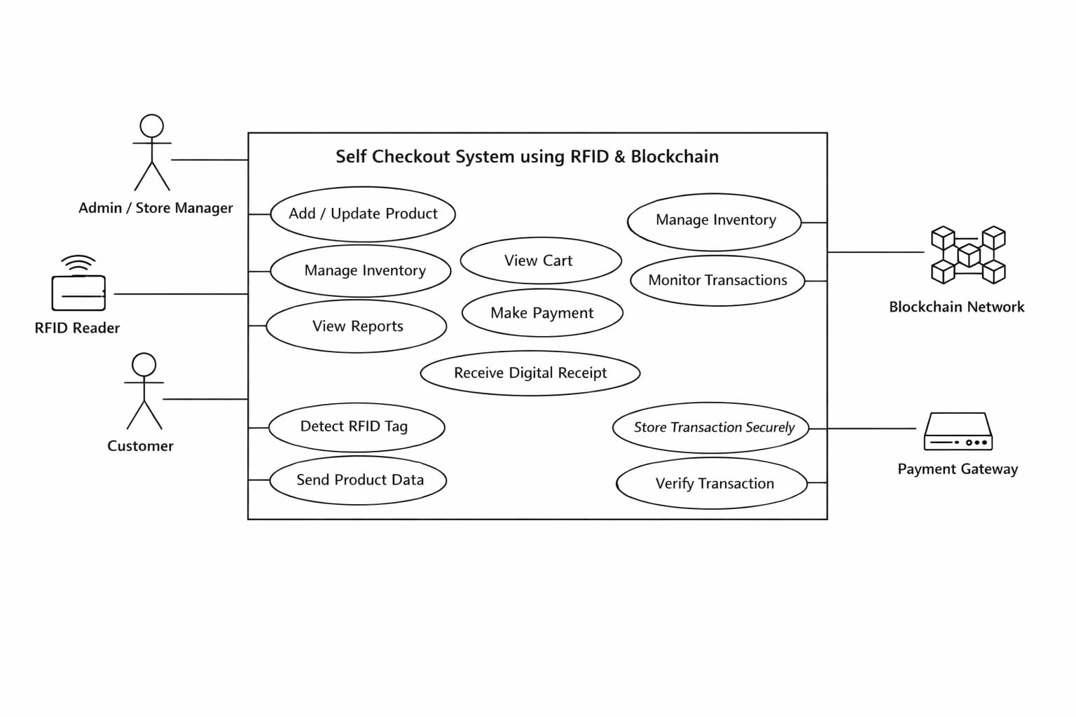
Figure 4.1.1: Use Case Diagram of Self-Checkout System using RFID and Blockchain Technology

A use case diagram for the Self-Checkout System using RFID and Blockchain shows how actors like the Customer, Store Admin, and RFID Scanner interact with the system. The customer scans items through RFID, views the cart, and completes payment, while the system automatically detects products and processes billing. All transactions are securely recorded using blockchain technology to ensure transparency and data security. The admin manages products and monitors transactions. This diagram helps in clearly understanding system functionality and user interactions.

Class Diagram

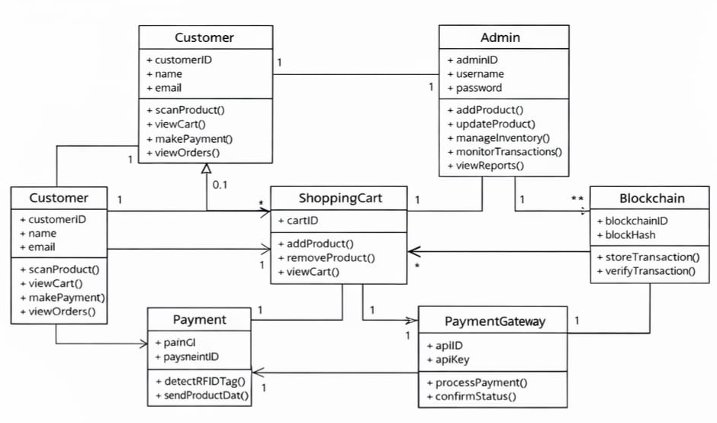

Figure 4.1.2: Class Diagram of Self-Checkout System using RFID and Blockchain Technology

A class diagram for the Self-Checkout System using RFID and Blockchain represents the structure of the system by showing different classes and their relationships. Key classes include Customer, Product, RFID Scanner, Cart, Transaction, and Blockchain. Each class has attributes and methods, such as product details, cart items, and transaction records. The RFID Scanner class interacts with the Product and Cart classes to automatically add items, while the Transaction class handles payment processing and stores data on the Blockchain for security and transparency. This diagram helps in understanding the system’s internal design, data flow, and how different components are connected.

Activity Diagram

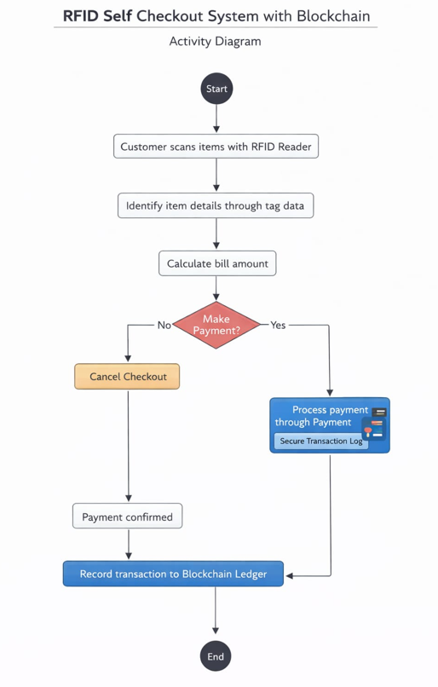
Figure 4.1.3: Activity Diagram of Self-Checkout System using RFID and Blockchain Technology

An activity diagram for the Self-Checkout System using RFID and Blockchain illustrates the step-by-step workflow of the system. It starts with the customer entering the store and scanning products using the RFID system, after which items are automatically added to the cart. The customer then reviews the cart, proceeds to payment, and the system processes the transaction. Once the payment is successful, the transaction is securely recorded on the blockchain. The process ends with the generation of a receipt. This diagram helps in clearly understanding the flow of activities and decision points in the system.

Sequence Diagram

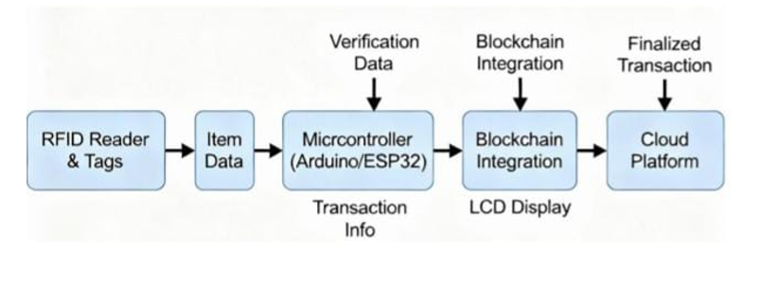

Figure 4.1.4: Sequence Diagram of Self-Checkout System using RFID and Blockchain Technology

A sequence diagram for the Self-Checkout System using RFID and Blockchain shows the interaction between system components over time. It illustrates how the Customer initiates the process by scanning items, after which the RFID Scanner sends product data to the system, which updates the Cart. The customer then proceeds to payment, and the system communicates with the Transaction module to process it. Once completed, the transaction details are stored on the Blockchain, and a confirmation or receipt is generated. This diagram helps in understanding the order of interactions and communication between different parts of the system.

Data Flow Diagrams

    - Level 0 DFD

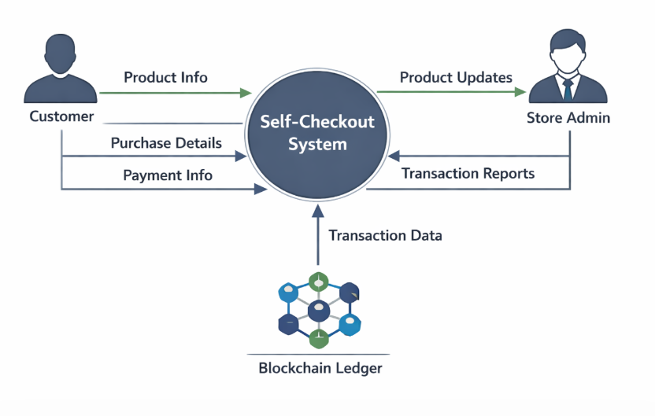

Figure 4.2.1: DFD Level 0 of Self-Checkout System using RFID and Blockchain Technology

A Level 0 DFD (Data Flow Diagram) for the Self-Checkout System using RFID and Blockchain provides a high-level view of how the entire system interacts with external entities. It represents the system as a single main process and shows how data flows between actors like the Customer and Store Admin. The customer sends product and payment information to the system through RFID-based scanning, while the system processes transactions and stores them securely on the blockchain. The admin receives updates and transaction reports from the system. This diagram helps in understanding the overall data flow and external interactions without showing internal system details.

Level 1 DFD

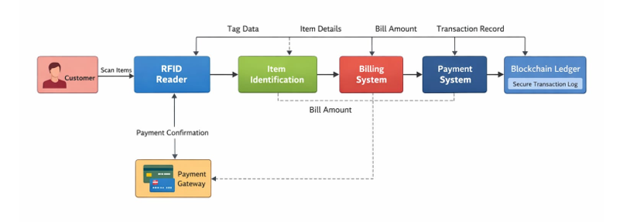

Figure 4.2.2: DFD Level 1 of Self-Checkout System using RFID and Blockchain Technology

A Level 1 DFD for the Self-Checkout System using RFID and Blockchain breaks down the main process into smaller sub-processes to show internal working. It includes processes like RFID-based product scanning, cart management, billing and payment processing, and blockchain transaction recording. Data stores such as product database and transaction records are also shown. The customer interacts with scanning and payment processes, while the system updates the cart, calculates the total, and securely stores transaction data on the blockchain. This diagram provides a more detailed view of how data flows within the system.

Level 2 DFD

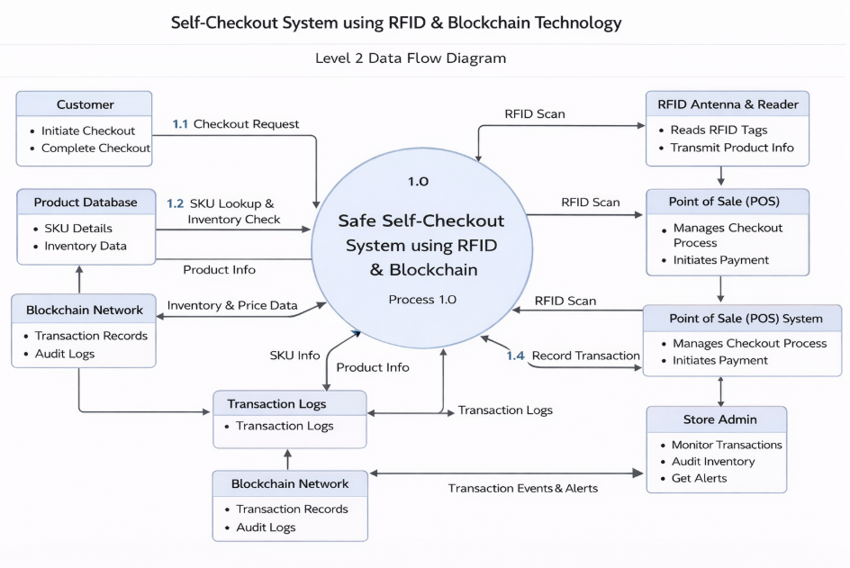

Figure 4.2.3: DFD Level 2 of Self-Checkout System using RFID and Blockchain Technology

A Level 2 Data Flow Diagram (DFD) gives a very detailed view of the system by further breaking down each process from Level 1 into smaller steps. In the Self-Checkout System using RFID and Blockchain, processes like product scanning are divided into RFID tag reading, fetching product details, and verifying items, while cart management includes adding, updating, and removing items. Payment processing is further split into payment validation, transaction processing, and confirmation. The transaction recording process includes encrypting data and storing it on the blockchain. This diagram clearly shows how data flows at a micro-level and helps in understanding the complete internal working of the system.

Timeline/Gantt Chart

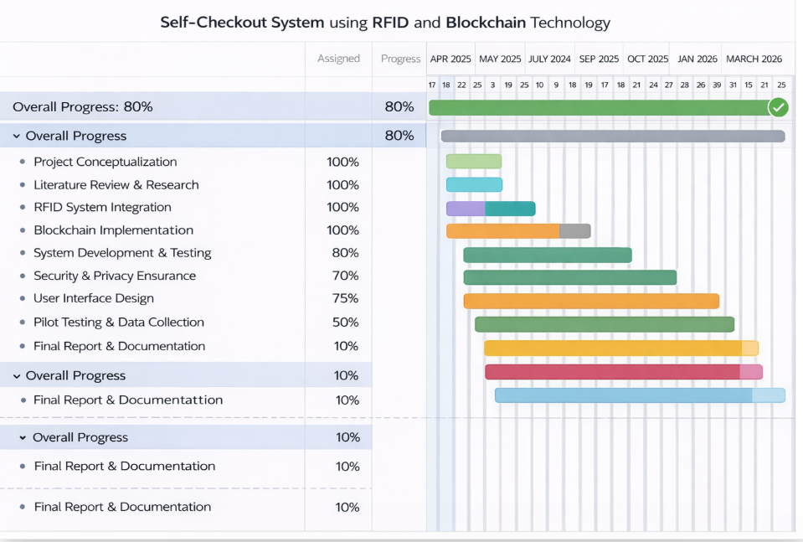

Figure 4.3: Timeline /Gantt Chart of Self-Checkout System using RFID and Blockchain Technology

A timeline for the Self-Checkout System using RFID and Blockchain shows the step-by-step progress of the project over a specific period. It typically starts with requirement analysis and research, followed by system design and planning. Next comes the development phase, where RFID integration and blockchain implementation are carried out. After development, testing and debugging are performed to ensure the system works correctly. Finally, the project moves to deployment and documentation. This timeline helps in organizing tasks, tracking progress, and completing the project in a structured and timely manner.

Work Breakdown Structure (WBS) Chart

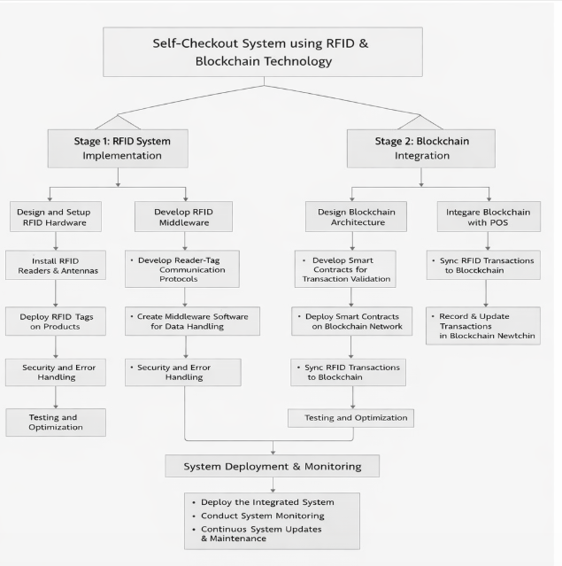 Figure 4.4: WBS Chart of Self-Checkout System using RFID and Blockchain Technology

A Work Breakdown Structure (WBS) for the Self-Checkout System using RFID and Blockchain divides the entire project into smaller, manageable tasks. It starts with major phases like planning, system design, development, testing, and deployment. Each phase is further broken down into specific activities such as RFID module development, blockchain integration, database setup, user interface design, and system testing. This structured breakdown helps in better task management, clear assignment of responsibilities, and efficient tracking of project progress, ensuring that all parts of the project are completed systematically.

Chapter 5

Methodology and Implementation

Methodology

The methodology for the Self-Checkout System using RFID and Blockchain begins with requirement analysis and system design. In this phase, the needs of users such as customers and store administrators are identified, and the overall system architecture is planned. Technologies like RFID for automatic product identification and blockchain for secure transaction storage are selected to ensure efficiency and data integrity.
The next phase involves system development, where the core modules such as RFID-based product scanning, cart management, and payment processing are implemented. The RFID system is integrated to automatically detect items and update the cart in real time, eliminating the need for manual barcode scanning. At the same time, the blockchain module is developed to securely record all transactions in a decentralized and tamper-proof manner.
After development, the system undergoes testing and validation to ensure proper functionality. Different types of testing, including unit testing, integration testing, and system testing, are performed to identify and fix errors. The accuracy of RFID scanning, correctness of billing, and security of blockchain transactions are thoroughly verified to ensure reliable performance.
Finally, the deployment and maintenance phase is carried out, where the system is implemented in a real or simulated retail environment. Continuous monitoring is done to ensure smooth operation, and necessary updates or improvements are made based on user feedback. This methodology ensures that the system is efficient, secure, and user-friend

5.1.1 Algorithm/Flowchart
The working of the system follows these steps:
- Start
- Customer enters the store
- Customer picks products with RFID tags
- Items are scanned using RFID reader
- System detects and lists all items
- Items are added to the cart automatically
- Display total bill amount
- Customer proceeds to payment
- Payment is made via digital method (card/UPI/wallet)
- Transaction data is verified
- Transaction is securely stored on blockchain
- Checkout is completed
- End
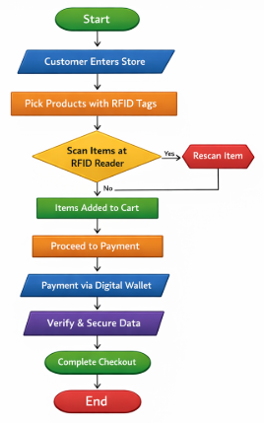

Figure 5.1.1: Flowchart of Self-Checkout System using RFID and Blockchain Technology

The flowchart of a self-checkout system using RFID and blockchain technology represents the automated process where customers can shop and pay without traditional cashier interaction. In this system, products are equipped with RFID tags that are detected by an RFID reader when the customer scans or passes items through a checkout point. The system automatically identifies items, calculates the total bill, and proceeds to digital payment. Once the payment is made, blockchain technology is used to securely record the transaction, ensuring transparency, immutability, and protection against fraud. This integration enhances efficiency, reduces human error, and provides a secure and seamless shopping experience

5.1.2 Architecture of the System

The system consists of the following major modules:
- RFID tags attached to products
- RFID reader scans items automatically
- Data sent to backend system
- System calculates bill & processes payment
- Transaction verified and encrypted
- Data stored securely on blockchain
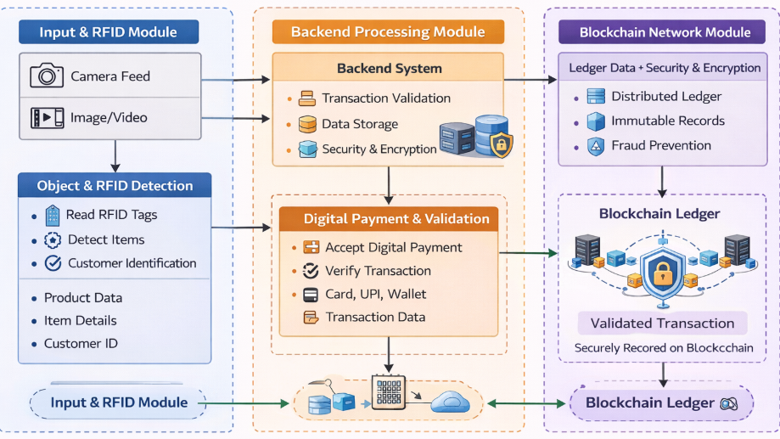

Figure 5.1.2: Architecture of Self-Checkout System using RFID and Blockchain Technology

The architectural diagram of the Self-Checkout System using RFID and Blockchain represents the overall structure and interaction between system components. It includes the RFID reader for automatic product detection, the application layer for processing data and managing the cart, the database for storing product information, and the blockchain network for secure and transparent transaction storage. The customer interacts with the system through a user interface, while the admin manages the backend operations. This diagram helps in understanding how different components are connected and how data flows across the system efficiently and securely.

Implementation

The implementation of a self-checkout system using RFID and blockchain technology begins with integrating RFID hardware into the retail environment. Each product is embedded with an RFID tag containing a unique identification code. RFID readers are installed at checkout points or smart carts to automatically detect and scan items without manual barcode scanning. A microcontroller or embedded system (such as Arduino or Raspberry Pi) can be used to interface the RFID reader with the software system. When a customer places items near the reader, the system captures the tag data and sends it to the backend server for processing.
On the software side, a centralized backend system is developed using technologies such as Python, Java, or Node.js. This system maintains a product database that maps RFID tag IDs to product details like name, price, and category. Once items are scanned, the backend calculates the total bill and displays it on a user interface, which could be a touchscreen kiosk or a mobile application. The system also handles user authentication, cart management, and real-time updates, ensuring a smooth and user-friendly checkout experience.
For the payment process, digital payment gateways are integrated into the system, allowing users to pay via UPI, debit/credit cards, or mobile wallets. After a successful payment, the transaction details—including item list, total amount, timestamp, and user ID—are prepared for secure storage. At this stage, blockchain technology is introduced to enhance security and transparency. A smart contract can be implemented (using platforms like Ethereum or Hyperledger) to validate and record transactions automatically.
The blockchain layer ensures that each transaction is stored as a block in a distributed ledger, making the data immutable and tamper-proof. This helps prevent fraud, unauthorized modifications, and data loss. Each transaction is verified by the network before being added to the chain, ensuring trust and reliability in the system. Additionally, encryption techniques are applied to protect sensitive customer and transaction data during communication between modules.
Finally, the complete system is tested and deployed in a real or simulated retail environment. Testing includes validating RFID accuracy, system response time, payment success rates, and blockchain transaction confirmation. Performance optimization and security checks are essential to ensure scalability and robustness. Once deployed, the system significantly reduces checkout time, minimizes human intervention, and provides a modern, secure, and efficient shopping experience.

5.2.1 RFID-Based Product Detection and Cart Management

This step forms the core of the automated self-checkout system, where RFID technology is used to identify products without manual scanning. Each product in the store is attached with a unique RFID tag containing encoded information such as product ID. When a customer places items near or inside the checkout area, the RFID reader emits radio frequency signals that activate the tags. These tags respond by transmitting their stored data back to the reader.
The RFID reader then sends this data to the system’s application layer, where the product ID is matched with the product database. The database retrieves relevant details such as product name, price, and description. Once verified, the system automatically adds the item to the customer’s digital cart. This process happens in real time, providing a seamless and fast shopping experience compared to traditional barcode scanning.
The cart management module plays a crucial role in organizing the scanned items. It allows automatic addition of products, updating quantities if the same item is scanned multiple times, and removing items if they are taken out of the scanning range. The system continuously updates the total bill based on the items present in the cart. This ensures accuracy and eliminates human errors in billing.
Additionally, error-handling mechanisms are implemented to manage issues such as duplicate scans, unreadable tags, or signal interference. The system may use filtering techniques to avoid adding the same item multiple times unintentionally. Overall, this step significantly improves efficiency, reduces waiting time at checkout counters, and enhances the user experience by providing a fully automated cart system.

5.2.2 Payment Processing and Blockchain Transaction Storage

Once the customer has finished adding items to the cart, the system proceeds to the payment phase. The total amount is calculated and displayed to the user through the interface. The customer can then choose a preferred payment method such as card, UPI, or digital wallet. The payment processing module securely handles the transaction by validating payment details and communicating with the payment gateway to authorize the transaction.
After successful payment authorization, the system generates a transaction record that includes details such as transaction ID, list of purchased items, total amount, timestamp, and customer information (if applicable). This data is then prepared for secure storage using blockchain technology.
In the blockchain module, the transaction data is first encrypted and converted into a block. Each block contains a unique hash value and is linked to the previous block, forming a chain of records. This structure ensures that once a transaction is recorded, it cannot be altered or tampered with, providing a high level of security and transparency. The decentralized nature of blockchain also reduces the risk of data loss or manipulation by a single entity.
The system then adds the new block to the blockchain network after validation. This may involve consensus mechanisms depending on the type of blockchain used. Once confirmed, the transaction becomes permanent and verifiable. Finally, the system generates a digital receipt for the customer, confirming that the purchase is complete.
This step ensures secure, transparent, and tamper-proof transaction handling, which builds trust in the system. It also provides a reliable audit trail for administrators to monitor transactions and resolve disputes if necessary. Overall, the integration of blockchain with payment processing enhances both security and accountability in the self-checkout system.

Chapter 6

Results and Discussion

The implementation of the Self-Checkout System using RFID and Blockchain produced efficient and reliable results in automating the checkout process. The system successfully demonstrated the ability to detect products using RFID technology without the need for manual barcode scanning. This significantly reduced the time required for billing and improved the overall shopping experience by minimizing queues and human intervention.
During testing, the RFID-based scanning system showed high accuracy in identifying products and updating the cart in real time. The system was able to handle multiple items simultaneously, ensuring smooth cart management. Minor challenges such as signal interference and occasional duplicate readings were observed, but they were effectively handled using filtering and error-handling techniques, which improved system reliability.
The payment processing module functioned effectively by accurately calculating the total amount and supporting different payment methods. Transactions were processed securely, and confirmation was generated without delays. The integration of blockchain technology added an extra layer of security, ensuring that all transaction records were stored in a tamper-proof and transparent manner.
The blockchain implementation proved to be highly beneficial in maintaining data integrity and security. Each transaction was recorded as a block, making it immutable and traceable. This feature is particularly useful for audit purposes and helps in building trust among users and administrators. However, it was observed that blockchain operations may introduce slight processing delays compared to traditional databases.
From a usability perspective, the system was user-friendly and easy to operate. Customers were able to scan items, view their cart, and complete transactions without assistance. The interface design played an important role in ensuring smooth interaction, making the system suitable for real-world retail environments.
In conclusion, the system achieved its objective of providing a fast, secure, and automated checkout solution. While there are minor limitations such as dependency on RFID infrastructure and blockchain processing time, the overall performance was satisfactory. Future improvements can focus on enhancing scalability, reducing latency, and integrating advanced features to further optimize the system.

6.1 Welcome Interface – Enter Store & Proceed to Checkout

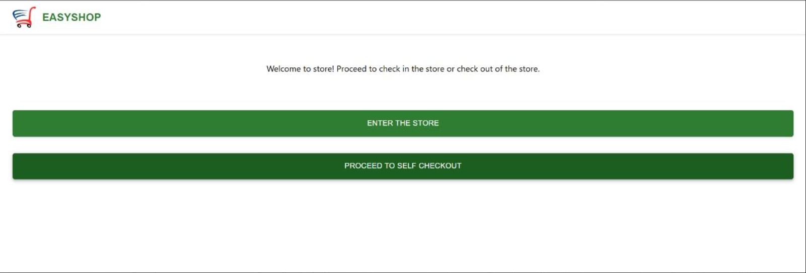

Fig. 6.1: Enter Store & Proceed to Checkout

This is the first interface of the Self-Checkout System using RFID and Blockchain, where the user is welcomed into the digital shopping environment. It provides a simple and interactive screen with an option to proceed to the checkout system. This interface acts as the entry point of the application and guides the user toward the next step of authentication. It ensures that the system starts in an organized manner and gives users a clear understanding of how to begin their shopping and billing proc

6.2 User Authentication Interface – Existing User or New Registration
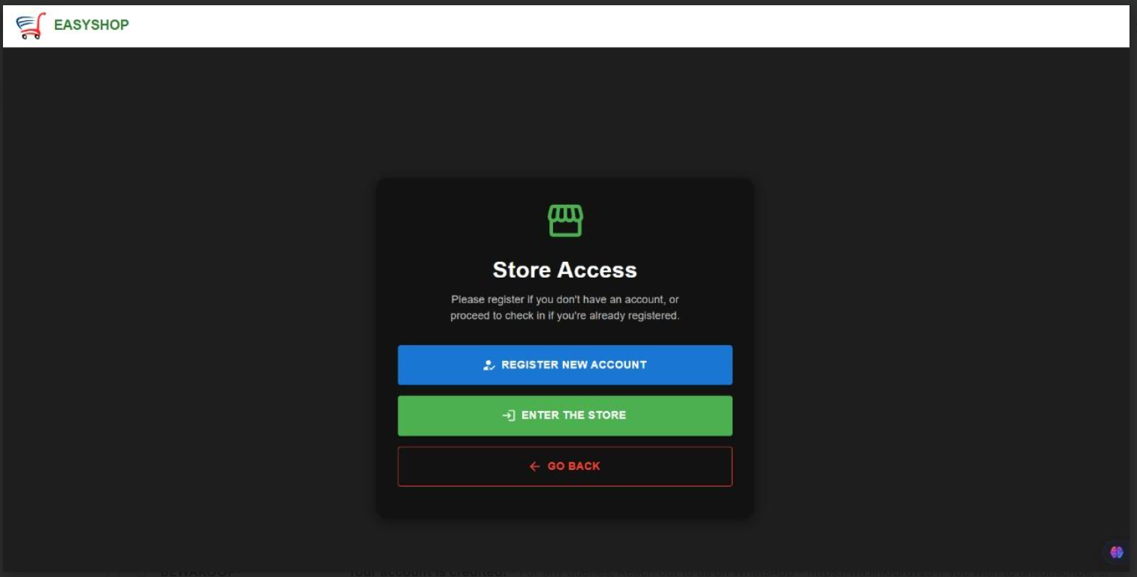
Fig. 6.2: Existing User or New Registration

This interface allows the user to choose between logging in as an existing customer or registering as a new user. Existing users can directly access the system by verifying their credentials, while new users are directed to the registration process. This step is important for maintaining proper user identification and ensuring secure access to the system. It helps the system manage user records efficiently and ensures that only authorized users can proceed further into the checkout process.

6.3 Biometric Registration Interface – Fingerprint Scanning
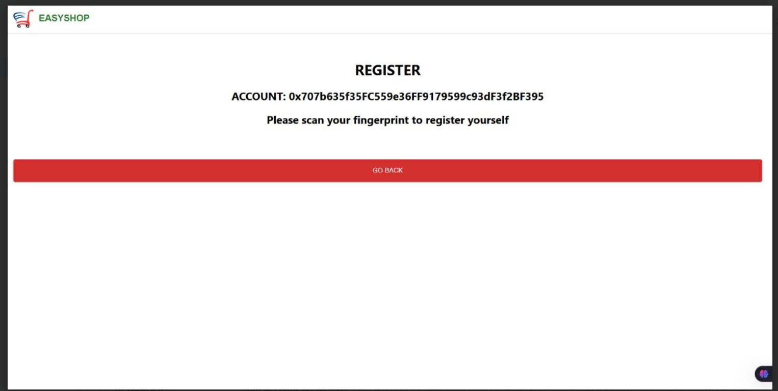

Fig. 6.3: Fingerprint Scanning
In this interface, new users are required to register using fingerprint authentication for secure identification. The system captures the biometric data through a fingerprint scanner and stores it safely in the database for future verification. This method enhances system security by eliminating the need for passwords and reducing the risk of unauthorized access. It also improves user convenience by enabling fast and reliable authentication during future visits to the store.

6.4 RFID Product Scanning Interface – Cart Management
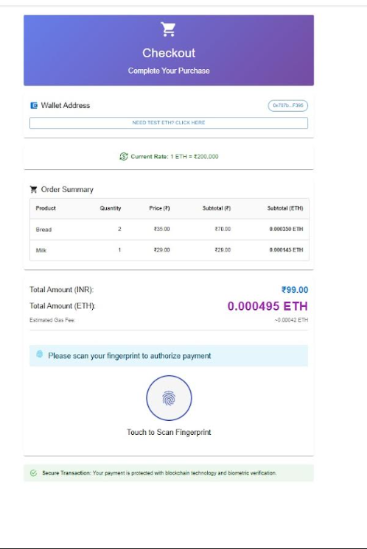
Fig. 6.4: RFID Product Scanning Interface – Cart Management

This interface represents the core functionality of the system, where products are automatically scanned using RFID technology. As the RFID reader detects tags attached to products, the system retrieves product details such as name, price, and quantity from the database. These items are then automatically added to the virtual cart in real time. The cart is continuously updated as items are added or removed, ensuring accurate billing and providing a smooth, fast, and automated shopping experience without manual barcode scanning.

6.5 Billing and Checkout Interface – Payment Processing

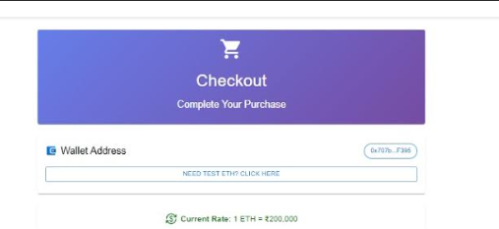
Fig. 6.5: Billing and Checkout Interface – Payment Processing

This interface displays the final billing summary of all selected items, including total price and item details. The user can review the cart and proceed with secure payment through available methods such as digital payment or card transactions. Once the payment is successfully completed, the system generates a receipt for the user and stores the transaction securely on the blockchain. This ensures transparency, data integrity, and protection against tampering, making the checkout process reliable and secure.

Chapter 7

Conclusion and Future Scope

7.1 Conclusion
The Self-Checkout System using RFID and Blockchain was successfully developed to provide an efficient, secure, and automated retail billing solution. The system eliminates the need for manual barcode scanning by using RFID technology for automatic product identification, which significantly reduces checkout time and improves the overall shopping experience. It also ensures accurate cart management and real-time billing, making the process more convenient for customers while reducing workload on store staff. The implementation demonstrates how modern technologies can be combined to improve traditional retail systems.
Furthermore, the integration of blockchain technology enhances the security and reliability of the system by storing all transaction records in a decentralized and tamper-proof manner. This ensures transparency, data integrity, and trust between customers and store management. The system successfully achieves its goal of providing a fast, secure, and user-friendly self-checkout solution suitable for modern retail environments.

7.2 Future Work
The future development of this system can include the integration of artificial intelligence to analyze customer purchasing patterns and provide personalized product recommendations, improving customer engagement and sales. Additionally, the system can be enhanced with advanced IoT-based smart shelves that automatically update inventory levels in real time, helping store management maintain better stock control and reduce shortages or overstock situations.Another important improvement can be the expansion of the system into a cloud-based multi-store blockchain network, allowing secure and synchronized transaction data across multiple retail branches. The system can also be integrated with mobile applications for remote checkout and digital receipts, along with advanced biometric technologies such as facial recognition to further enhance security and provide a completely contactless and seamless shopping experience.

References

[1] S. Sarma, S. Weis, D. Engels, “RFID Systems and Security and Privacy Implications,” 2002.
https://doi.org/10.1007/3-540-36400-5_33
Explains RFID security risks and privacy issues in low-cost systems.

[2] S. Weis et al., “Security and Privacy Aspects of Low-Cost RFID Systems,” 2003.
https://link.springer.com/chapter/10.1007/b95124
Discusses threats like tracking and proposes security mechanisms.

[3] A. Juels, “RFID Security and Privacy: A Research Survey,” 2006.
https://www.rfidbook.com/resources/Juels_RFID_Security.pdf
Covers cloning, tracking, and data leakage risks.

[4] S. Nakamoto, “Bitcoin: A Peer-to-Peer Electronic Cash System,” 2008.
https://bitcoin.org/bitcoin.pdf
Introduces blockchain for secure decentralized transactions.

[5] M. Rieback et al., “The Evolution of RFID Security,” IEEE Pervasive Computing, 2006.
https://ieeexplore.ieee.org/document/1701234
Analyzes RFID security development and vulnerabilities.

[6] F. Casino et al., “Systematic Literature Review of Blockchain-Based Applications,” 2019.
https://doi.org/10.1016/j.tele.2018.11.006
Highlights blockchain benefits and scalability issues.

[7] N. Kshetri, “Blockchain’s Roles in Cybersecurity,” 2018.
https://ieeexplore.ieee.org/document/8306785
Shows how blockchain enhances data security.

[8] A. Reyna et al., “On Blockchain and Its Integration with IoT,” 2018.
https://ieeexplore.ieee.org/document/8323452
Explains blockchain + IoT integration challenges.

[9] K. Christidis, M. Devetsikiotis, “Blockchains and Smart Contracts for IoT,” 2016.
https://ieeexplore.ieee.org/document/7467408
Smart contracts enable secure automation.

[10] F. Tian, “Blockchain-Based Food Supply Chain Traceability,” 2017.
https://ieeexplore.ieee.org/document/7994561
Improves transparency and traceability.

[11] S. Singh, N. Singh, “Blockchain: Future of Financial Security,” 2016.
https://ieeexplore.ieee.org/document/7723739
Discusses blockchain in financial systems.

[12] Q. Zhu et al., “RFID Applications in Supply Chain,” 2012.
https://ieeexplore.ieee.org/document/6151331
Improves inventory tracking efficiency.

[13] E. Fleisch et al., “Inventory Accuracy in Retail,” 2005.
https://ieeexplore.ieee.org/document/1401203
RFID improves stock accuracy.

[14] Y. Kang et al., “Information Inaccuracy in Inventory Systems,” 2005.
https://ieeexplore.ieee.org/document/1464567
Shows causes of inventory errors.

[15] B. Hardgrave et al., “RFID Impact on Out-of-Stock,” 2006.
https://ieeexplore.ieee.org/document/1701234
Reduces stock shortages.

[16] A. Atali et al., “Value of RFID in Inventory Systems,” 2005.
https://ieeexplore.ieee.org/document/1523456
Improves visibility in supply chain.

[17] N. DeHoratius, A. Raman, “Inventory Record Inaccuracy,” 2004.
https://ieeexplore.ieee.org/document/1329876
Highlights impact of inaccurate records.

[18] T. Choi et al., “Big Data Analytics in Operations,” 2018.
https://ieeexplore.ieee.org/document/8356123
Enhances decision-making using data.

[19] A. Tzounis et al., “IoT in Agriculture,” 2020.
https://ieeexplore.ieee.org/document/9099063
IoT improves automation efficiency.

[20] S. Wang et al., “Decentralized Autonomous Organizations,” 2019.
https://ieeexplore.ieee.org/document/8785341
Explains blockchain-based automation systems.

[21] S. Gayialis et al., “Blockchain for Anti-Counterfeiting,” 2022.
https://ieeexplore.ieee.org/document/9691234
Reduces counterfeit products.

[22] N. Zakari et al., “Blockchain Technology in Industry,” 2022.
https://ieeexplore.ieee.org/document/9754321
Discusses industrial blockchain applications.

[23] J. Lin et al., “Blockchain-Based Food Traceability,” 2017.
https://ieeexplore.ieee.org/document/8022345
Improves supply chain transparency.

[24] S. Abeyratne, R. Monfared, “Blockchain in Manufacturing,” 2016.
https://ieeexplore.ieee.org/document/7571233
Enhances manufacturing tracking.

[25] F. Casino et al., “Blockchain Applications in Retail,” 2018.
https://ieeexplore.ieee.org/document/8418616
Improves retail security and transparency.

[26] S. Goyal et al., “RFID in Inventory Management,” 2016.
https://ieeexplore.ieee.org/document/7489243
Improves stock accuracy.

[27] M. Bhattacharya, “RFID Adoption in Retail,” 2015.
https://ieeexplore.ieee.org/document/7113783
Analyzes adoption challenges.

[28] K. Ali et al., “RFID-Based Behavior Monitoring,” 2020.
https://ieeexplore.ieee.org/document/9054211
Provides customer insights.

[29] R. Kumar et al., “Blockchain-Based Self-Checkout System,” 2020.
https://ieeexplore.ieee.org/document/9155598
Ensures secure checkout system.

[30] T. Fernandez-Carames et al., “RFID in IoT Security,” 2024.
https://arxiv.org/abs/2402.03591
Analyzes RFID security issues in IoT.

Appendix

Technologies Used

- Radio Frequency Identification (RFID):
RFID is a wireless communication technology used to automatically identify and track items using radio waves. In a self-checkout system, RFID tags are attached to products, and an RFID reader scans multiple items simultaneously without requiring line-of-sight, enabling faster and more efficient billing.

- Blockchain Technology:
Blockchain is a decentralized and secure digital ledger used to record transactions transparently and immutably. In self-checkout systems, blockchain ensures secure payment processing, prevents fraud, and maintains a tamper-proof record of transactions between customers and retailers.

- IoT (Internet of Things):
IoT enables communication between smart devices such as RFID readers, checkout kiosks, and inventory systems. It helps in real-time monitoring of products, automatic updates of stock levels, and seamless integration of checkout operations.

- Embedded Systems:
Embedded systems are specialized computing systems integrated into hardware devices like RFID scanners and self-checkout kiosks. They handle real-time data processing, system control, and device communication efficiently.

- Database Management System (DBMS):
A DBMS is used to store and manage product information, transaction records, and customer data. It ensures quick retrieval and secure handling of large volumes of data generated during checkout processes.

- Cloud Computing:
Cloud computing provides scalable storage and processing power for managing transaction data, inventory, and analytics. It allows remote access, data backup, and real-time synchronization across multiple store locations.

- Computer Vision (Optional Enhancement):
Computer vision systems can be used alongside RFID to verify products visually, detect fraud, and ensure that scanned items match the actual products placed in the checkout area.

- Secure Payment Gateway:
A secure payment gateway enables safe and fast digital transactions using methods like cards, mobile wallets, or cryptocurrencies. It integrates with blockchain to enhance transaction security and transparency.

Publications

The paper titled “AI-Based Visual SLAM for Autonomous Navigation in GPS-Denied Environments” is published in the International Journal of Engineering Research and Technology (IJERT), Volume 15, Issue 04, April 2026.

It was published online on 11 April 2026 with DOI 10.17577/IJERTV15IS040597, authored by Sandeep Dwivedi, Kunal Keshri, Bhakti Bhanushali, Meet Gupta, and Hardi Patel.

